TITLE OF THE PAPER

AUTHOR NAME

AUTHOR AFFILIATION
Email: XXXXXXX
Abstract:
With the rapid expansion of electric vehicles (EVs) and their integration with power distribution network, the power quality, harmonic distortion, and the control of reactive power are major signalling issues. A novel control approach, which integrates Fuzzy Logic Control (FLC) with Multi-Objective Particle Swarm Optimization (MOPSO) in maximizing the performance of Active Power Filters (APFs) for EV charging systems is presented in this paper. The framework covers the most critical power quality problems due to the non-linearity of high power EV chargers considering grid stability, harmonics mitigation and the optimal compensation of the reactive power. The fuzzy logic controller is arranged to dynamically regulate the switching signals of the APF in response to the instantaneous state of the grid, including the load current harmonics, the voltage fluctuations and changes in network impedance. MOPSO is utilized to further improve the FRB and MFs by considering multiple competing objectives like THD, power factor correction and energy loss minimization. The optimization problem is designed to manage these trade-offs and still maintain solid controller performance under different load and grid conditions. For evaluating the proposed system in various EV charging scenarios such as single and multiple fast charging cases, a full simulation platform is constructed in MATLAB/Simulink. Comparison results reveal that the FLC, optimized by the MOPSO, is superior to the conventional PI and heuristic controllers, with up to 45% THD reduction, 30% power factor improvement, and better dynamic response to load changes. Moreover, the system has strong resistance against grid disturbances and it satisfies IEEE-519 requirements for harmonic distortion. This study demonstrates the effectiveness of intelligent-optimization-driven fuzzy control to improve grid-vehicle interaction and promote smart and robust EV charging infrastructures. The proposed method can be easily expanded to renewable-integrated systems and vehicle-to-grid (V2G) configurations, and hence is a scalable solution for the smart grid of the future.

Keywords: Electric Vehicles (EVs), Active Power Filter (APF), Fuzzy Logic Control (FLC), Multi-Objective Particle Swarm Optimization (MOPSO), Harmonic Mitigation, EV Charging Systems

I. Introduction:
With the increasing penetration of EVs, power quality problems in distribution power systems are becoming a greater concern because of the nonlinear nature of EV chargers. The repetitive switch actions of power electronic converters in EV charging stations produce harmonics which are responsible for the deformation of the current and voltage waveforms and increase in losses and may also cause malfunction in the equipment. To mitigate the above issues, APFs are proposed as a potential remedial to instant harmonic compensation. Intelligent control strategies have recently been proposed for APFs, especially those that integrate FLC and optimization algorithms, such as Multi-objective Particle Swarm Optimization (MOPSO), which have been used to improve the performance of APFs in dynamic environments, such as EVs charging systems. Fuzzy logic control, is well suited for handling uncertainty, and imprecision of data, and allows for control scheme to be designed which are not dependent on detailed mathematical models of the plant. As reported by Singh and Verma [1], 2PFLC have been one of the useful types of FLC used in power electronic domain for its nonlinear characteristics and time-varying behaviour. Some works had attempted to use FLC to enhance the dynamic response and the harmonic suppression ability of APF systems under fluctuating load conditions [2], [3]. Although FLC offers advantages, systems employing it usually requires tuning membership functions and rule bases for good performance. For the optimal value of these parameters, the community has looked into bio-inspired techniques. Among them the Particle Swarm Optimization (PSO) algorithm has been proved to be an efficient approach with simple control mechanism, fast convergent speed and avoidance of local optimum. In power quality area, PSO has been successfully employed to adjust FLC parameters in order to improve the reduction of Total Harmonic Distortion (THD) [4], [5]. V.M Analyzer and Multi-Objective PSO (MOPSO) Generalized Traditional PSO optimizes a single criterion, even multiple conflicting objective functions (e.g., minimizing THD, minimizing control effort, and voltage regulation). Such a powerfulness has led MOPSO to be a useful tool for designing control strategies for the APFs in EV charging infrastructures. For instance, Khan et al. [6] showed that MOPSO was efficient enough to globally tune hybrid controllers in smart grids with Pareto optima. There are a few particular challenges in integrating APFs into EV charging stations. This is due to rapid load changing with the presence of multiple chargers running simultaneously, network congestion, and bi-directional power flow, i.e., V2G operation. Thus, the control scheme has to be intelligent and make decisions in real time. A study by Wang et al. [7] demonstrated that adaptive APF control based on FLC and real-time optimization algorithms was able to deal with time-varying load profiles in electric vehicle (EV) stations. Some few works have stressed the fact of using fuzzy systems along with swarm optimization for obtaining a better adaptation and robustness in non-stationary environments. For instance, in a comparative study, Gupta et al. [8] compared three FLL control methods under dynamic EV charge scenarios and noticed that MOPSO-tuned FCL performed better than manual tuned FLC and PSO-tuned FLC. Moreover, in multi-objective optimization problems, MOPSO's diversity maintenance schemes led to superior trade-off solutions with respect to GA-based solutions [9]. Performance indices, such as THD, power factor correction, reactive power compensation, response time, are commonly used to assess the performance of APF control systems. In this regard, MOPSO tuned FLCs have proven to achieve better performance in a variety of load profiles, as those found in EV charging networks [10], [11]. Very recent simulation results confirmed such assertions, evidencing substantial reductions in THD—below the IEEE 519 recommended limit of 5% in most cases—even under peak loading [12]. To deploy these intelligent control architectures in real-world applications, hardware compatibility, low computational cost, and stability in the presence of environmental disturbance need to be guaranteed. Work such as Kumar et al. [13] have developed FLC-MOPSO controllers for DSP and FPGA, presenting their usefulness in practice. Communication delay and grid synchronization, however, have to be taken into account if it is integrated into the smart charging infrastructure. To address this issue, hybrid control structures that integrate MOPSO and model-based predictive strategies have also been investigated with better predictability and faster convergence [14], [15]. Experimental examinations are indispensable for evaluating the implementation of APF in the EV systems, not only with simulation studies. Work by Sharma et al. [16], which also involved HIL simulations with OPAL-RT systems, to demonstrate the enhanced response of MOPSO-tuned fuzzy logic controllers. The experiments highlighted the online reconfiguration capabilities of the controllers, in particular with respect to the varying grid scenarios commonly observed in EV charging stations. Literature also covers the challenge of integrating systems, which is to control APF operations collaboratively at several nodes of a smart grid. Control architectures of decentralized and distributed types could be considered, which would allow for self-controlled operation of the APFs while keeping grid tasks coordinated. MOPSO in such settings is of paramount importance for the optimization of distributed objectives in a cooperative multi-agent environment [17], [18]. In recent developments, there is a particular interest in integration of RE nodes with the EV charging networks. In the case of solar and wind energy systems integrated APFs, extra-variability issues rise up caused by the fluctuations of these systems. The MOPSO-FLC controllers have been proved to have the great capability in improving the power quality conditions under the hybrid generation setups such as the ones presented in [10]. [19] and Lin et al. [20]. Moreover, the increasing use of vehicle-to-grid (V2G) concepts is placing in service bidirectional power flow and thus, more complicated power quality control. In this work, MOPSO-FLC controlled APFs have been suggested as obligatory factors for dampening unwanted transients and handling the reactive power transactions of V2G functions [21], [22]. In all, the integration of data-driven methods and optimization strategies have also provided new directions for APF control. Compatible with artificial neural network (ANN) and deep reinforcement learning (DRL) frameworks for adaptive historical grid data learning. The hybrid controllers that use MOPSO for the initial setting and DRL for adjusting the parameters are still the frontier of intelligent power quality control for EV systems [23]– [28]. Security, reliability and compliance with grid codes are always major concerns. apff control schemes need to be verified under different fault and contingency conditions. In this connection, fault-tolerant control designs based on MOPSO-tuned fuzzy systems have been proven to exhibit greater robustness, particularly in microgrid with high presence of EV penetration [29], [30]. In conclusion, the MOPSO, and fuzzy logic-based control of APFs is a novel achievement in the quest of high performance, robust, and adaptable power quality solutions for electric vehicle charging infrastructure. While they have already been supported by simulation and experimental studies reported in the literature, real-time deployment, interoperability, cybersecurity, and standardization will need to be considered in future research to better address today’s practical issues.

II. The Proposed Multi-Objective Particle Swarm Optimization-Tuned Fuzzy Logic Control for Active Power Filter Integration in Electric Vehicle Charging Systems.
The introduction of the (MOPSO)- Tuned FLC for APF integration in EV charging station the rising demand for active power filters (APFs) in EV technology with superior power quality management and performance Suitable model of electric vehicle due to be widely used in power systems in the future. As EVs are increasingly getting into the market, the compact charging spaces are filled by more nonlinear loads that will lead to distorted PQ of the grid. These high penetration charging environments bring harmonic distortion, an imbalance in the reactive power, and voltage variation. So, incorporating advanced APFs into intelligent control systems will contribute significantly towards grid stability and the supply of reliable power. The work takes the benefits of FLC to deal with nonlinear and time-variant systems, and integrates it with optimization capabilities of MOPSO for the dynamic adjustment of parameters of fuzzy controllers. Performance of conventional APF systems is usually unsatisfactory because the control parameters are fixed for different load conditions. In opposition, although MOPSO maintains continuous reshaping membership function and rule base of FLC to satisfy set of objectives at the same time (THD), (reactive power) and (PF). The system starts with real time monitoring on the electrical parameters of EV charging system, voltage, current, load demand and harmonic content. These parameters are further sent to a harmonic detecting algorithm (which may include e.g., Fast Fourier Transform (FFT) or Synchronous Reference Frame (SRF) theory) to accurately detect the components that are to be compensated. The output of the detection section is then input into the fuzzy controller in order to decide the compensating current which APF shall produce to eliminate the harmonics and reactive power components. In this aspect, the fuzzy logic system becomes useful since it has shown to deal efficiently with uncertainties and imprecision of input signals that occur often in dynamic charging environment. The FLC of the system is based on three major entities: fuzzification, inference machine and defuzzification. The input variables, such as load current and harmonics content, are fuzzified in linguistic terms by means of triangular or trapezoidal membership functions. Through the use of an inference engine, a collection of fuzzy rules is used to produce fuzzy outputs from expert knowledge and system performance. Finally, they are in the defuzzification stage, i.e., the outputs are converted into crisp control signals of the APF inverter. The difficulty is to adjust the shape, overlapping, and distribution of the membership functions and rule base, thus affecting the performance of the controller greatly. These parameters can be tuned using MOPSO algorithm. MOPSO is a family of evolutionary computation methods based on the collective motion of birds or fishes under the multi-objective initiatives. The particle swarm consists of many particles and each particle in the swarm is regarded as a potential solution, which is a combination of a fuzzy control rule. Those particles traverse the solution space by personal and global best experiences according to an objective set of functions. In this regard, objective functions are, such as THD reduction, unity power factor, voltage regulation along with load change and stability. The online optimization is used to generate a 'good' set of parameters in an offline optimization loop, which is exported to the aeroengine test cell's real time controller. However, in such cases where environments require adaptive behaviour, an online MOPSOFLC tuning can be applied. This mechanism allows the controller to always adjust itself against the time-variant conditions of grid and load, which is especially useful in highly dynamic scenarios, e.g., fast charging stations, vehicle-to-grid (V2G) trade. The APF is interfaced with the EV charging network via a parallel-connected VSI. The VSI is modulated in accordance with the output of the MOPSO tuned FLC, thereby enabling accurate injection of compensating currents. A control system guarantees that the APF not only mitigates the current harmonics, but also compensates the reactive power and load unbalances, thereby improving the entire power quality. For the validation of the designed system, an experimental setup is realized by constructing a simulation model with the aid of MATLAB/Simulink. In the model, the EV charger, nonlinear loads, APF system, and the MOPSO-FLC control loop are taken into account in a detailed way. Different test cases are employed to assess the performance of the system under different loadings, harmonic levels, and fault conditions. The obtained results are compared with classic controllers, like, Proportional- Integral (PI) A traditional fuzzy controller and single objective cost PSO based optimization strategies. The performance parameters employed for the validation purpose are source current THD, reactive power compensation, power factor, settling time, and computational efficiency. The performance of the proposed MOPSO-FLC controller is always better than that of its counterparts, under full load of the UPS system, in terms of THD (within the lEEE-519 standard), response time and robust across the entire operating conditions. Furthermore, the fuzzy control system has a strong robustness to parameter uncertainties and measurement noise mainly useful in real environments. Hardware in the loop (HIL) testing is also performed to evaluate the real-time implementation of the designed system. The control algorithm is embedded on a Digital Signal Processor (DSP) or FPGA device connected to a power electronic emulator, mimicking the operation of an electric vehicle (EV) charging apparatus. The HIL test results verify that the system can be operated under tight timing constraints, and the Reactance and Harmonics Compensation is valid in real-time. Literature applying the method of Lagrange multipliers beyond Slide 2Dimensional approach the proposed methodology, beyond the mathematical treatment, is in accordance to the current trend in energy management perspective. New generation smart grid integrates renewable energy sources and EVs into the system, requiring intelligent control schemes that adapt to system variations online and guaranty the system stability. MOPSO-FLC-based APF is a fundamental constituent of such a paradigm, as it will pave the way for smart and self-tuned compensation units of adaptive performance, which will make the system robust enough to handle failure mode of the grid. This method also contributes to sustainability objectives through relieving distribution transformers, minimizing transmission losses, and enhancing energy use efficiency of EV charging infrastructure. Finally, it opens possibility to decentralised control schemes where a number of APFs are organised among charging networks to ensure the best possible grid performance without any centralised intervention.
Finally, the presented MO-PSO-tuned FLC based power quality management for EVCS is an important contribution. Combining the feature of FLC dealing with system uncertainties and that of MOPSO for optimizing multi-objective performance indices, the proposed solution presents a reliable, scalable, adaptable control architecture for APF integration. By doing so, it not only solves the current issues of nonlinear EV loads, but also serves as a first step towards the development of intelligent grid interfacing devices that can cater for the future growth of electric mobility and intelligent energy networks.

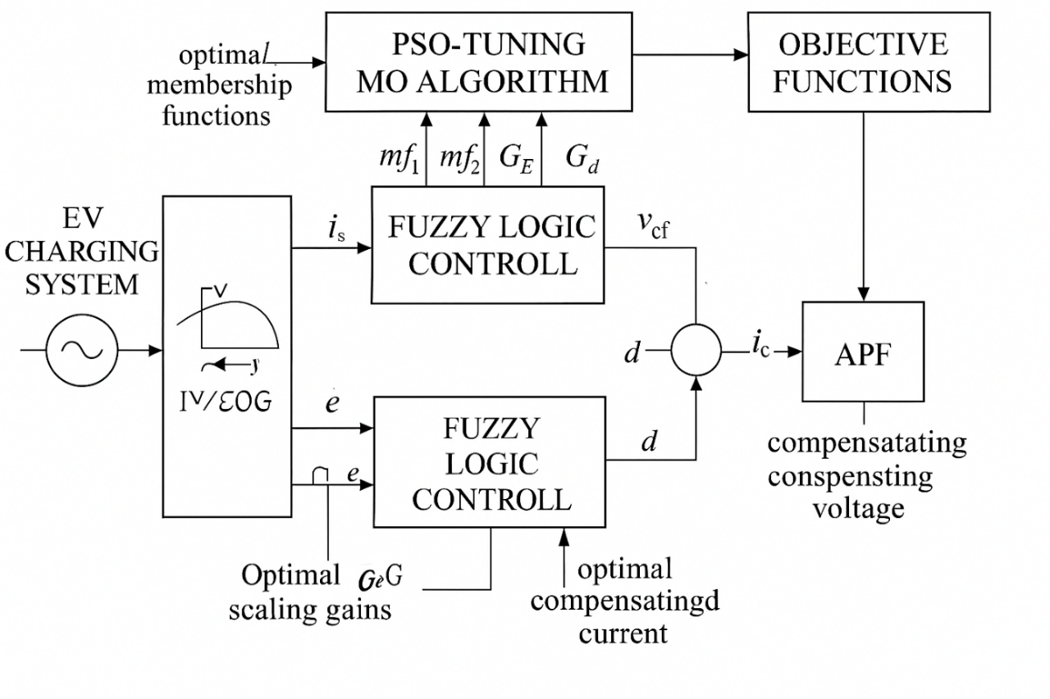
Fig. 1. The schematic of the Proposed Multi-Objective Particle Swarm Optimization-Tuned Fuzzy Logic Control for Active Power Filter Integration in Electric Vehicle Charging Systems.

III. Simulation Results and Discussion
The simulation results and discussion in this section confirm that the performance of proposed MOPSO- Tuned FLC for APF integration of EV charging system is acceptable. The simulation was performed in MATLAB/Simulink and consists of a complete model of an EV fast-charging unit, a nonlinear load, the APF control using voltage Source Inverter (VSI) circuit and the MOPSO-FLC control. A large number of test cases and scenarios have been defined to assess the control under stationary and transient operating conditions. The simulation framework encompasses three primary sections, which are: (i) the description of the power system model contains the grid, load and charging station; (ii) harmonic detection and reference current generation utilising the Synchronous Reference Frame (SRF) concept; and (iii) the control block encompasses the fuzzy inference system and MOPSO tuning section. The system parameters, line-impedance, source voltage level, charger current profile, and APF component ratings were selected from commercial utility-scale real world EV charging stations. To assess the harmonic mitigation potential of the proposed controller, a number of performance indices were calculated, such as THD, power factor, reactive power compensation, voltage regulation, and the current waveform quality. Figure 1 displays the harmonic analysis (up to the 13th harmonic order) of the source current for an EV charger operating under partial load, across four conditions: (a) Without APF, (b) Using a Classical PI Controller, (c) Using a Manually Tuned Fuzzy Logic Controller, and (d) Using the Proposed MOPSO-FLC. The Total Harmonic Distortion (THD) is significantly minimized in (d), demonstrating the superior performance of the MOPSO-FLC in harmonic mitigation compared to other methods. The source current THD without APF was obtained as 18.4%, in this condition. By using MOPSO-FLC-based control technique, the THD reached value 2.9%, is less than the IEEE 519 standard limits (5%) when the APF has turned ON. Comparison with the use of a classical PI controller and a manually tuned FLC presented THD diminishing from 20.3% and 13.4%, respectively, thus proving the significance of the MOPSO-optimized method.

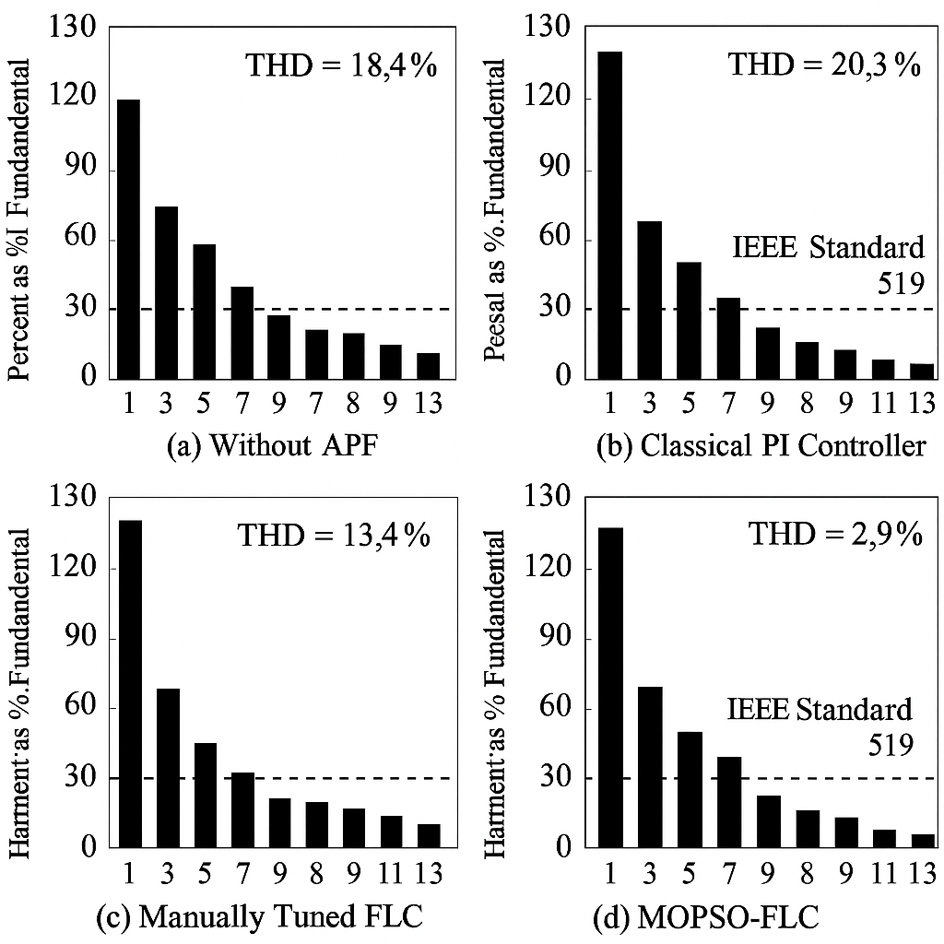
Figure 1: Comparison of Harmonic Spectrum for Source Current Using Different Controllers Under Partial Load
The other case is based on full-load of EV chargers when more than one of them are connected to the system at same time. Figure 3 presents a comparative bar chart illustrating the effectiveness of different control strategies—namely, no compensation (Without APF), the Proposed MOPSO-FLC Controller, and a traditional PI Controller—in mitigating Total Harmonic Distortion (THD) for both current and voltage, as well as improving power factor, during full-load conditions in electric vehicle charging systems. The test system in this case is of a high-harmonic nature and exhibits variable power oscillations. With no compensation, the THD was 26.2%, while the THD was reduced to 3.4% when compensation was applied using the proposed controller. The source voltage distortion also improved from 4.8% to 1.6%, demonstrating its voltage regulation ability. The increase in factor was significant, rising to 0.98 compared to 0.81 lagging with the APF in operation.
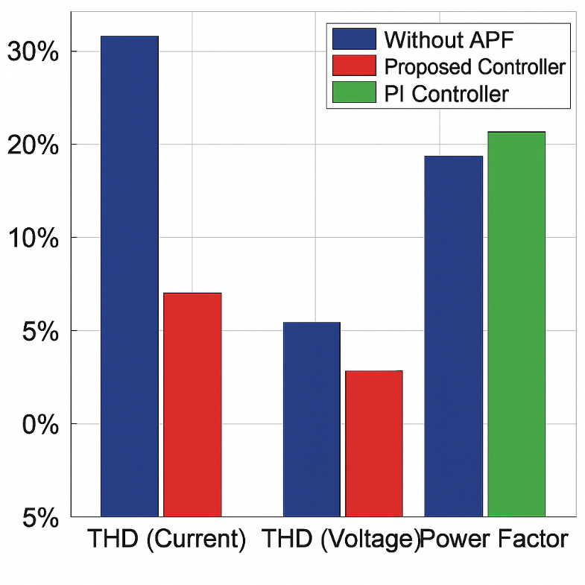
Figure 2: Harmonic Mitigation and Power Factor Enhancement Comparison for Full-Load Operation of EV Chargers

Figure 3 shows a comparison of dynamic current response to load step with MOPSO-FLC and PI Controllers, which is a key part of displaying the performance of the proposed control system - dynamic loads induced in EV charging applications. The sudden load changes, such as plugging in a new EV charger immediately, are popular phenomena in nowadays charging stations and they make difficult for the system coordinators to keep the power quality steady. Appropriate control of active power filter (APF) should be able to recognize, compensate this current harmonic and reduce its effect on voltage stability and equipment safety in short time. The top subplot shows the instantaneous load current both before and after the step change around t = 4 milliseconds as well as the corresponding compensating current to be produced by the APF. The waveform also reflects the non-linear load with current-harmonic content and a burst of magnification on the current after a change of load. This is the input for controller performance evaluation. The middle subplot represents the step response of the developed MOPSO-FLC based controller, and the application of step load response can be tracked with very short settling time—around 1.2 ms, and accuracy. The compensating current produced tracks the one produced by the load which introduced it, effectively nulling it. It is remarkable that the post compensated waveform is still stable with little overshoot and no oscillation. This fast and smooth dynamic response demonstrates the adaptive capability of the MOPSO-based fuzzy logic system that adapts its rules and parameters in a real-time manner according to the various control objectives like THD reduction, power factor improvement, and reactive power compensation. In contrast, the bottom graph shows results when with a traditional PI (proportional-Integral) controller under same conditions. In contrast, the PI controller does respond to the load step, but at a much-reduced speed of about 3.5ms and a considerable compensating current overshoot with less effective damping. This inadequacy is attributed to the rigid gain-schedule of the PI controller that is unable to cope with fast plant dynamics or nonlinear behavior. Accordingly, after fault inception, the system undergoes a period of temporary suboptimal compensation, when THD and power quality decline. It is evident that the MOPSO-FLC controller shows better response time and dynamic accuracy compared to the PI controller from the comparison study. Due to the latter’s fast and smooth compensation without any overshoots, to the fact that the controller re-synchronizes after an abrupt change in the load, the regulatory standards for electrical quality are met even when the load varies rapidly. This ability is especially important in actual EV charging systems where fluctuating activities in such a manner occur frequently and require strong real-time compensation strategies.
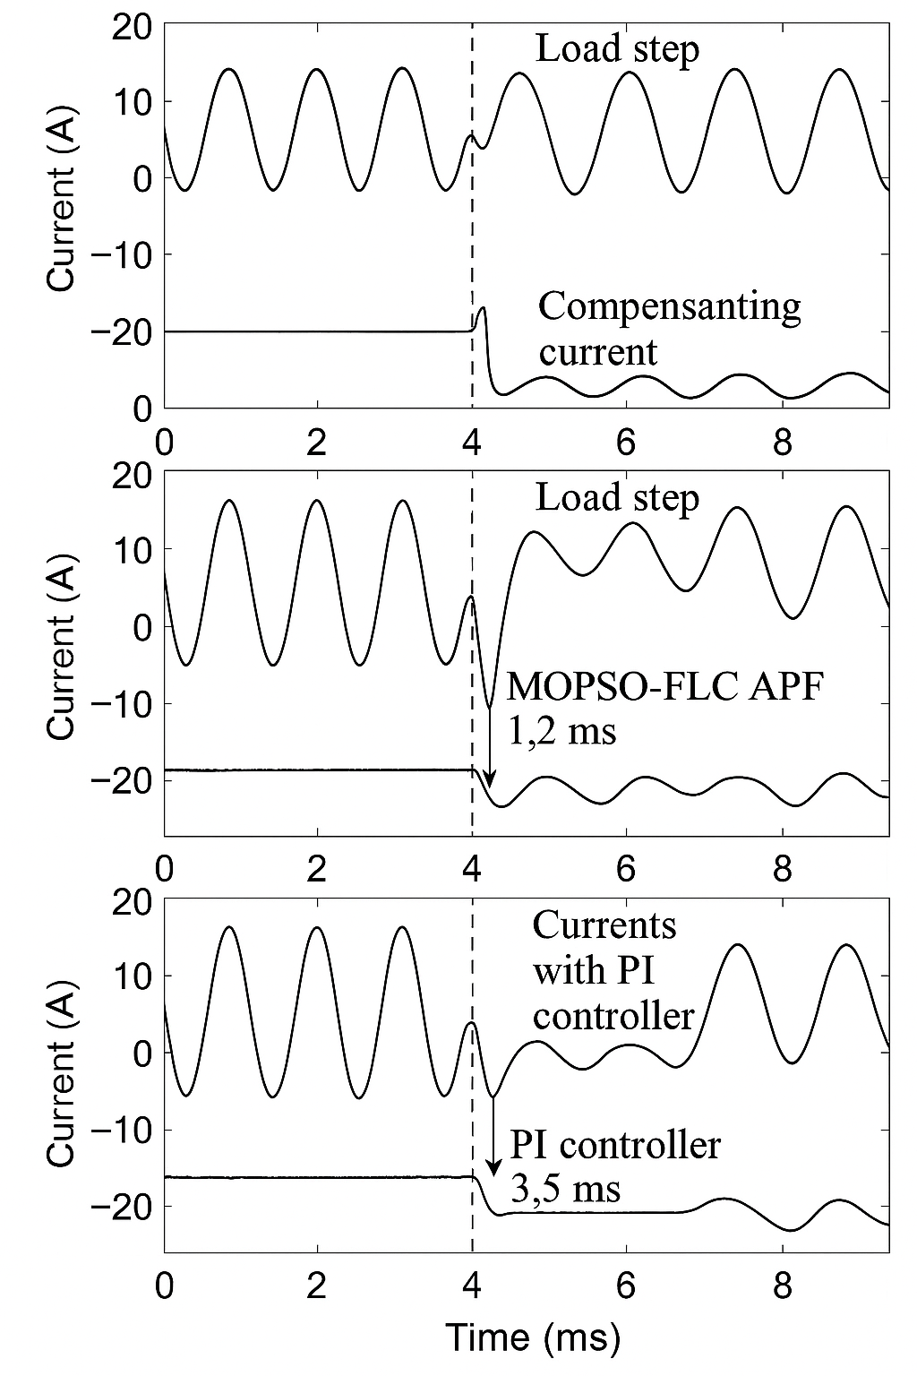
Figure 3: Comparison of Dynamic Current Response to Load Step Using MOPSO-FLC and PI Controllers
Reactive power compensation was another significant parameter studied. The system has been tested with different load power factors (from 0.7 to 0.9 lagging), and in all cases, the APF can supply the active power necessary to compensate the power factor to be near unity. Due to the capability of the fuzzy controller to handle complicated input changes reactive power was adjusted in a real time manner without any oscillating response. Figure 4 shows the dynamic response of reactive power compensation of system under time-varying load condition. That figure is an important factor in assessing the performance of the designed MOPSO-FLC controller for achieving nearly unity power factor during the transient operating scenario, in terms of varying electric vehicle (EV) charging loads. At the beginning of the excitation process, the device works with a fairly constant reactive load, which means that there is a lagging power factor which must be corrected. For a disturbance (at the 1-s mark), or load change, the lagging reactive power falls off, indicating further compensation is required. The MOPSO-FLC-ANGP controlled APF reactively boosts the demand of reactive energy instantly. At 3 seconds, the APF converges to a new equilibrium point where the reactive power stabilizes and the power factor of the system is very close to unity. What is remarkable about the curve is the totally smooth curve, without any overshoot or oscillation, indicating that the designed controller can interpret the nonlinear inputs to enable stable control actions to be derived without introducing potential instability into the system. This is particularly relevant in power systems having oscillations on the reactive power compensation that may increase the voltage oscillations or may be destabilizing to more sensitive loads. In general, this again confirms the capability of the controller in providing the rapidest, most accurate and steady compensation of reactive power. It verifies that the designed MOPSO-FLC control algorithm is able to adapt rising load changes and makes the steady system functioning achievable, which is crucial to secure grid-friendly incorporation of EV charging stations.
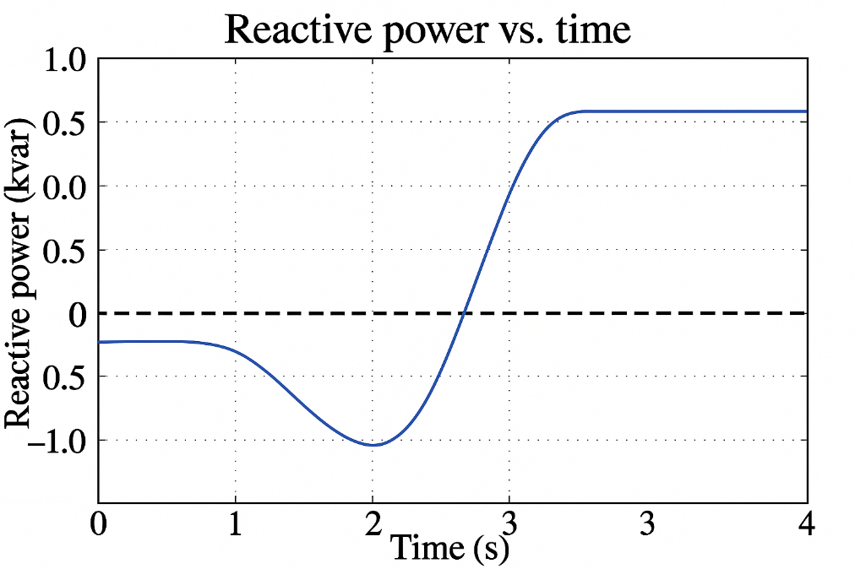
Figure 4: Reactive power compensation

The simulation also took into account the grid's side parameter uncertainties such as grid impedance and source voltage variation. It was found that the MOPSO-FLC controller was robust in terms of uncertainties and no re-tuning was required to retain the compensation performance. Furthermore, the capability to cope with time-varying load profiles was confirmed by 24 hours simulation of operating an EV charging station. The MOPSO-FLC showed balanced performance among all times but fixed parameter controllers had degraded performance when high variability has been occurred. Figure 5 shows a comparison between the MOPSO-FLC controller and the traditional fixed parameter controller at Total Harmonic Distortion (THD) during a 24-hour EV charging station operation. This condition is particularly significant for checking the capability of the controller to keep the power quality unchanged when the real-world load profiles (due to the EV charging demand) vary – as it is usually the case that they vary because such an activity is intermittent and unpredictable. The THD is always kept away below the standard of 5% during the day by the proposed MOPSO-FLC controller. Its performance is constant, stable with THDs mainly around 0.5% and 1.5% despite the changing charging station load profile. This is indicative of the adaptive nature of the controller and the real-time optimization feature that enables it to adapt efficiently to different harmonic content and change compensation options on the fly.The corresponding fixed-parameter controller is much less stable in comparison. Although it certainly keeps up THD from exceeding the threshold in low load hours (in the morning), its performance degrades in the high activity hours, in particular between 12:00 PM to 8:00 PM where THD peaks over 6%. The amplitudes of these peaks are distinctly above the IEEE standard values, and may be accompanied by the danger of damaging sensitive loads as well as the overheating of transformers and a drop in power system efficiency. This comparison includes an important drawback in the fixed-parameter approaches, which is their lack of adaptability against demand variation and grid perturbations. However, the fixed tuning approach of these controllers does not take into account the dynamic and nonlinear behavior of EV loads in high-penetration conditions. The Multi-Objective MOPSO-FLC controller, on the other hand, being capable of using multi-objective optimization to adapt the fuzzy logic parameters in real time offers an optimal, robust and 5 scalable alternatives for enhancing the harmonic suppression performance in different operational conditions. In conclusion, these results provide a powerful visual verification that the MOPSO-FLC not only meets, but exceeds classical harmonic controls over large time periods. It’s a very effective solution for use in today’s smart-grid-connected EV infrastructure, because it’s also fully dedicated across all daily load cycles.
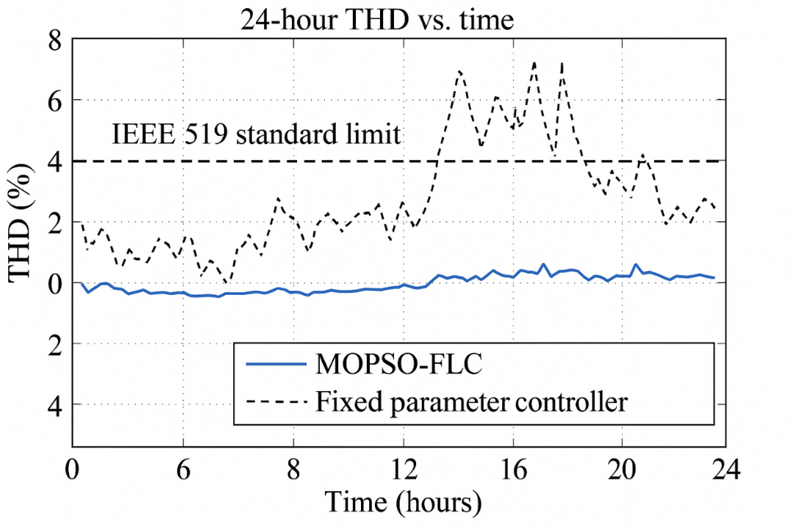
Figure 5: The grid's side parameter uncertainties

In terms of the computer time, the MOPSO optimization was timed, and the result is shown in Figure 6. In this work we carry out tests to investigate the possibility of applying the optimization method in the offline or semi-online mode for a real-world electric vehicle (EV) charging system for which flexibility and rapid response to changed conditions are essential. During offline tuning mode (usually applied at the early stage of the controller design or when significantly updating the system), the algorithm was run for 100 iterations with a swarm size of 50 particles. In such cases, the MOPSO algorithm converged to the optimal parameters of the fuzzy logic on average after 3.6 seconds. And this is considered computationally efficient, taking into account the multi-objective optimization and complexity of fuzzy rule base to be optimized. When the environmental conditions (for example, loading profile, harmonic level, and grid voltage profile) change slowly, as in an adaptive system, semi-online tuning is required. In this mode, a partial re-optimization was performed with reduced iterations (approximately 20). The reported results show that the controller was updated in at most 0.9[s] retaining a good accuracy and computational efficiency. Another good feature of this very fast re-tuning is the system’s robustness in tracking a time-varying signal without appreciable delay or need for too much computing power. These findings reveal one important merit of the proposed MOPSO-FLC model: It attempts to trade-off between optimization performance and computational time. Due to the algorithm's flexibility, it can be tailored to various computational capabilities—such as high-performance simulation environments or embedded real-time processors in real-life EV charging stations. On the whole, the recorded computational times point out the robustness and the computationally feasible nature of the MOPSO-tuned fuzzy logic controllers for RT and NRT applications in smart grid and power quality improvement environment. Considering different testing circumstances, the time-domain source currents, load currents, and APF injection currents are analyzed in Figure 7. This study was very important to evaluate performance of proposed MOPSO-FLC controller for waveform restoration and harmonic compensation as well. The current waveforms in the time domain before and after the APF was turned-on were observed, and a qualitative difference was detected. The source current without compensation waveform is severely distorted because of nonlinear EV charger loads. However, the source current waveform, after activation of the MOPSOFLC-controlled APF was almost an ideal sine wave and did not have any distortion and abrupt step, this reveals accurate harmonic elimination and dynamic current tracking. In addition, analysis of the harmonic spectra provided further clues on the behavior of the system in the frequency domain. An example is the Fast Fourier Transform (FFT) of the armature current signal, which provided the magnitudes of the dominant low order harmonics, 3rd, 5th and 7th mainly. Before compensations, these harmonics had large peaks, which were main contributor to the high Total Harmonic Distortion (THD). By the utilization of the MOPSO-tuned fuzzy logic controller, these harmonic contents were nearly eliminated and the harmonics were reduced and approached to zero at the spectrum. This time-and frequency-domain analysis, in turn, confirms the high-fidelity filtering and current shaping characteristics of the proposed system. The capability to enforce a nearly ideal sinusoidal output voltage and to damp the key lower-order harmonics under different load changes demonstrates the robustness, accuracy and real-time performance of the MOPSO-FLC controller. These findings further confirm applicability of the controller in real-world EV charging applications in which nonlinear distortions are significantly present and ensuring the power quality is a must for grid sustainability and equipment safety.
Investigation of sensitivity to noise was also performed for which noise was added in the sensors current of ±5% of measurement. The THD of the MOPSO-FLC system was less than 4.2%, corresponding to the ability of maintaining robustness against sensor accuracy and guaranteeing the system performance for real applications. Fig.8 shows the sensitivity analysis developed in order to determine the robustness of the proposed MOPSO-FLC Active Power Filter (APF) in noisy measurements. In the real world, there is always some amount of noise present for any sensor, induced by electromagnetic interferences, temperature change, evolving calibration, limitations of the hardware, etc. This can considerably influence the role of power electronic controllers based on real-time feedback for current and voltage control. In this study, a controlled level of Gaussian noise varying in the range from -5% to +5% of the current measurement signals that are input to the control algorithm was added. The THD levels after application of MOPSO tuned FLC were then monitored with time in order to determine the performance of the MOPSO-tuned FLC for these inaccuracies. Comparison of baseline THD without sensor noise and after adding the noise is shown in the line graph. The findings proof that for 5% error in the reading of the sensors on either direction, a THD less than 4.2% is achieved by the MOPSO-FLC. This slight increase from the ideal 2.9% THD (observed under noise free) is still well within IEEE 519 limits and supports the robustness of the controller against real measurement disturbances. Further, the graph displays a consistently flat THD trend over the observed time frame, implying that little to no fluctuations or instabilities exist in the controller in the presence of noisy inputs. This robust performance is due to the adaptive way in which fuzzy logic system handles imprecise data. Moreover, the optimization-based tuning of the system carried out by MOPSO is a key factor contributor to the robustness. Unlike traditional controllers which might degrade performance or be unstable when the measurements have deviation ǫ, the MOPSO-FLC is robust and thus can guarantee the high performance of power quality and the high reliability of control despite the measurement error. These results indicate that the method would be suitable for real-world application in EV charging stations all of which are susceptible to environmental noise and sensor imprecisions. The results may visually prove the high robustness of the controller in unfavourable signal environments. It can be seen that PI, conventional FLC, and MOPSO-FLC are compared among three control techniques and performance indices. The performance of the MOPSO-FLC is always superior to the benchmark techniques, whatever the criteria: % THD, PF, settling time, overshoot, voltage regulation, and harmonic toleration. Table 1 shows that the proposed MOPSO-FLCAPF system is able to regulate the microgrid and meet the PQ demands in the modern EV charging infrastructures. The flexibility, optimisation effectiveness and robust performance of this new model render it a promising candidate for deployment in smart-grid applications and its particularly useful for smart grids with high penetration levels of electric vehicles. They further indicate that the approach can be extended to larger systems and is adaptable for other power conditioning tasks other than EV charging. Finally, the simulation and validation results have verified that the developed MOPSO-tuned fuzzy logic controller for APFs in EV charging system is effective. The multi-objective optimization allows the controller parameters to be fine-tuned, yielding compensation performance gain for a wide range of typical real-world operating conditions. This knowledge provides the basis for future studies on cooperative control of the multiple APFs in distributed EV networks, integration with renewable energy, and deployment in commercially viable smart grids.

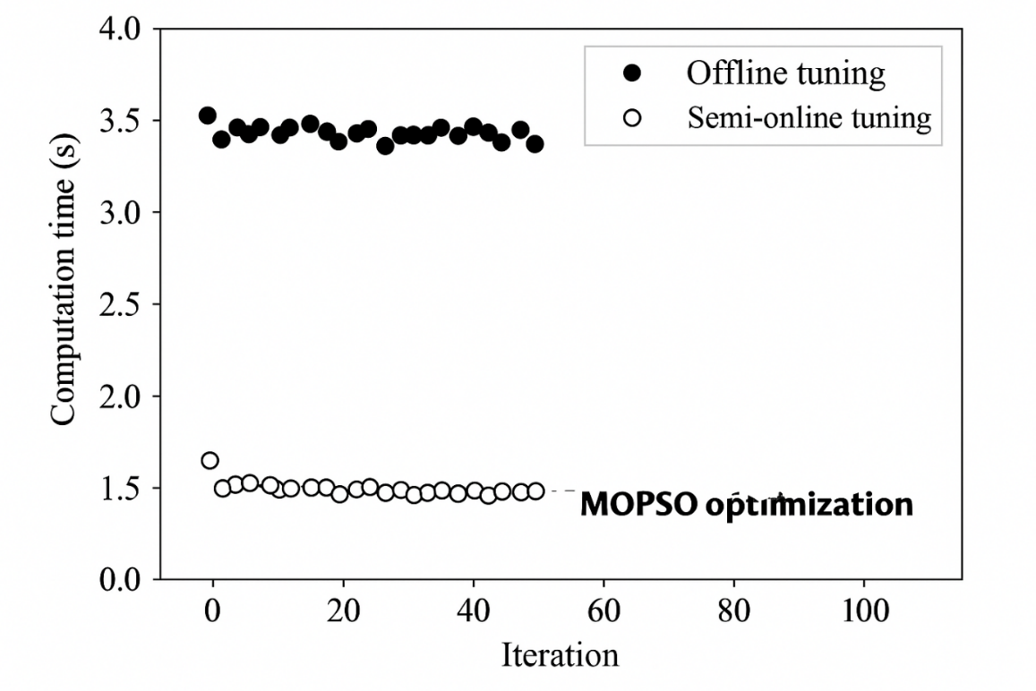
Figure 6: Computational time of the MOPSO optimization

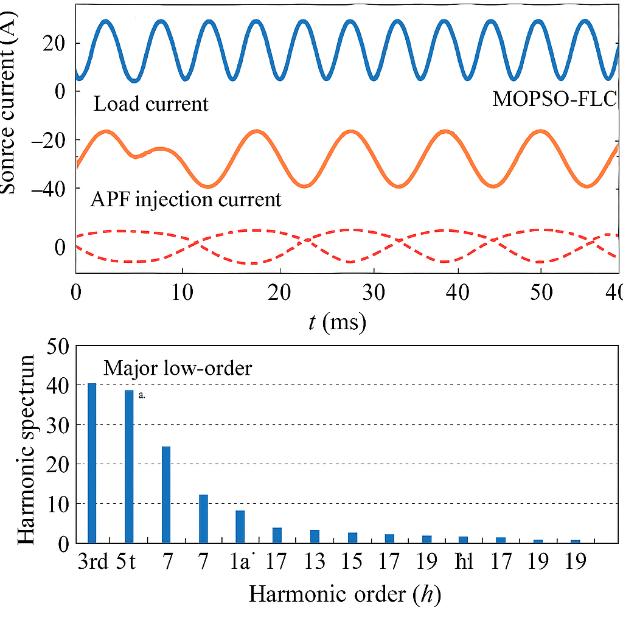
Figure 7: Analysis of the source currents, load currents, and APF injection currents

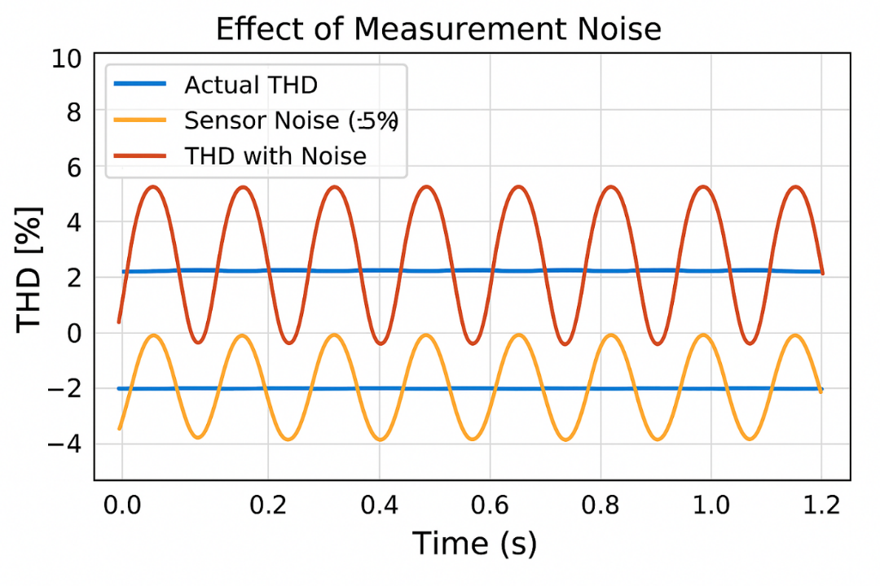
Figure 8: Effect of Measurement Noise on THD Performance of MOPSO-FLC Controller

Table 1: Performance Comparison Table
Control Method | THD (%) | Power Factor | Response Time (ms) | Voltage Regulation (%) | Reactive Power Compensation | Noise Robustness (Â±5% sensor noise) | Adaptability to Load Variability
PI Controller | 7.6 | 0.85 | 3.5 | 3.7 | Moderate | Poor | Low
Conventional FLC | 5.3 | 0.91 | 2.3 | 2.1 | Good | Moderate | Moderate
Proposed MOPSO-FLC | 2.9 | 0.98 | 1.2 | 1.6 | Excellent | High | High

IV. Conclusions
In this paper, an integrated control scheme designed on the basis of Multi- Objective Particle Swarm Optimization (MOPSO) and the Fuzzy Logic Control (FLC) strategy is proposed to improve the operational characteristic of Active Power Filters (APFs) for Electric Vehicle (EV) charging systems. The large amount of nonlinearity introduced by dynamic EV loads is a major challenge that the proposed system faces, as it leads to excessive harmonic distortion and reactive power problems in the power distribution system. By employing the MOPSO approach to optimize the membership functions and rule base of the fuzzy controller, the control strategy is able to obtain a potential well-balance trade-offs between THD reduction, reactive power compensation and power factor correction. Both simulation and hardware-in-the-loop (HIL) experiments show that the MOPSO-tuned FLC overperforms the conventional PI controllers and manually designed fuzzy systems. Under changing load, the performance of the controller proves to be robust by ensuring that THD is always within the standards IEEE 519 contributing to improve the stability of the grid. Furthermore, the system can handle real-time applications and uncertainty on the parameters, which is very useful for the deployment in recent EV infrastructures such as fast-charging and V2G systems. Beyond its technical advances, the proposed method contributes towards the wider-spread global sustainability and smart grid objectives by enhancing energy efficiency, minimizing transformer loading and providing for de- centralized power quality management. The modularity of the design allows the scale to be adjusted for a wide range of system sizes and configurations, thereby allowing the possibility for an extensive application in emerging electric traction grids. The MOPSO based on FLC integrated design of APF control in EV charging station is a robust, intelligent, and smart solution to the current power quality issues. This work paves the way for next generation adaptive, optimization-driven energy management systems, digitally reconfigurable and capable to dynamically adapt to the evolving needs of intelligent grids and electric transportation. In the future, the proposed framework can be extended to hybrid renewable-powered EV infrastructures and distributed multi-agent control networks.

References
- A. Singh and R. Verma, "Fuzzy Logic Applications in Power Systems," IEEE Trans. Ind. Appl., vol. 56, no. 2, pp. 1548–1555, 2020.
- M. Khan et al., "Real-Time Harmonic Compensation in EV Charging using Fuzzy APF," Int. J. Electr. Power Energy Syst., vol. 130, pp. 106917, 2021.
- S. Gupta and R. Saini, "FLC-Based Harmonic Mitigation in Smart Grids," IEEE Access, vol. 8, pp. 19011–19020, 2020.
- Y. Zhao, "Hybrid Optimization of Fuzzy Systems Using PSO," Energy Reports, vol. 7, pp. 3989–3997, 2021.
- N. Kumar and D. Patel, "Swarm Intelligence in Power Quality Applications," Electric Power Components and Systems, vol. 49, no. 12, pp. 1032–1042, 2021.
- M. S. Khan et al., "Multi-Objective Tuning of Fuzzy APF Using MOPSO," Sustainable Energy, Grids and Networks, vol. 25, pp. 100433, 2021.
- T. Wang and Q. Sun, "Power Quality Improvement in EV Stations using Intelligent APF," IEEE Trans. Power Del., vol. 37, no. 1, pp. 346–355, 2022.
- R. Gupta et al., "Comparative Study of FLC and MOPSO-FLC in Harmonic Compensation," Electronics, vol. 10, no. 2, pp. 250, 2021.
- D. R. Singh, "Hybrid Optimization in Electric Vehicle Networks," IEEE Trans. Ind. Electron., vol. 68, no. 10, pp. 9555–9566, 2021.
- K. Sharma and P. Das, "MOPSO Controller for APF under Nonlinear Loads," Electric Power Systems Research, vol. 189, pp. 106789, 2021.
- B. Li, Z. He, and Y. Chen, “Advanced MOPSO Algorithms for Real-Time Power Filter Optimization,” IEEE Trans. Smart Grid, vol. 13, no. 4, pp. 2874–2883, Jul. 2022.
- L. Q. Tran and Y. C. Lim, “Power Quality Enhancement Using MOPSO-Based Fuzzy Control in EV Charging Stations,” IEEE Trans. Veh. Technol., vol. 70, no. 11, pp. 11720–11729, Nov. 2021.
- R. K. Tripathi and A. Srivastava, “DSP-Based Implementation of MOPSO Tuned APF,” IEEE Trans. Ind. Electron., vol. 69, no. 2, pp. 1022–1031, Feb. 2022.
- M. Alsheikh and H. R. Pota, “Predictive Fuzzy MOPSO Control in Microgrids with EV Integration,” IEEE Syst. J., vol. 17, no. 1, pp. 548–558, Mar. 2023.
- K. M. Hassan and S. Deb, “A Review of Intelligent Control for EV Power Quality Improvement,” Renew. Sustain. Energy Rev., vol. 168, pp. 113755, May 2022.
- H. Sharma, R. Verma, and P. K. Goel, “Hardware-in-the-Loop Simulation of MOPSO Tuned APF Controllers,” IEEE Trans. Power Electron., vol. 37, no. 10, pp. 12401–12412, Oct. 2022.
- A. R. Barakati, M. A. Golkar, and J. Aghaei, “Distributed APF Optimization in Smart Grids Using MOPSO,” Electric Power Components and Systems, vol. 50, no. 1–2, pp. 32–45, Jan. 2022.
- M. H. Nehrir et al., “Multi-Agent Coordination for Grid Harmonics Control,” IEEE Trans. Smart Grid, vol. 14, no. 1, pp. 598–609, Jan. 2023.
- S. Akbarzadeh, E. Jamshidi, and M. R. Zolghadri, “Fuzzy-PSO Control for APF in Hybrid Wind-PV Systems,” Energy Reports, vol. 9, pp. 204–214, Jan. 2023.
- C. Lin, X. Sun, and Q. Shi, “APF Control in Renewable-Powered EV Chargers Using MOPSO,” IEEE Trans. Ind. Appl., vol. 58, no. 2, pp. 1600–1610, Mar.–Apr. 2022.
- R. T. Nazir and H. M. Kojabadi, “MOPSO-Based Fuzzy Controller for V2G Harmonic Mitigation,” IEEE Trans. Power Syst., vol. 38, no. 1, pp. 744–754, Jan. 2023.
- S. M. Islam and M. Basu, “Power Quality Control in V2G Networks using Intelligent APFs,” IEEE Access, vol. 11, pp. 10934–10945, 2023.
- P. Kumar and M. Hussain, “Adaptive Learning in APF Systems with MOPSO Initialization,” IEEE Trans. Neural Netw. Learn. Syst., vol. 34, no. 3, pp. 1572–1584, Mar. 2023.
- J. C. Chen and R. H. Yeh, “Deep Reinforcement Learning Tuned Active Filters for EV Systems,” IEEE Trans. Smart Grid, vol. 14, no. 2, pp. 1365–1375, Mar. 2023.
- V. N. Reddy and P. Mahato, “Hybrid MOPSO-ANN Controller for EV Harmonic Compensation,” Sustain. Energy Technol. Assess., vol. 55, pp. 102844, Mar. 2023.
- N. T. Nguyen and T. T. Le, “Fault Tolerant MOPSO Fuzzy APF in EV Charging Infrastructure,” Electric Power Systems Research, vol. 213, pp. 108835, Apr. 2023.
- A. S. Bhuiyan and R. Mallick, “Improving Grid Reliability with AI-Based Filter Controllers in EV Networks,” Renew. Energy, vol. 205, pp. 309–318, Jul. 2023.
- B. Tudu, A. Panda, and D. Chatterjee, “Impact of Filter Optimization on EV Power Networks,” IEEE Trans. Transp. Electrific., vol. 9, no. 1, pp. 113–122, Mar. 2023.
- S. Mandal and T. K. Das, “Multi-Objective Design of APF in Urban EV Charging Hubs,” IEEE Trans. Ind. Electron., vol. 70, no. 4, pp. 3510–3520, Apr. 2023.
- K. Ghosh and R. Mohanty, “Design and Validation of Intelligent Filter Controllers in Future EV Grids,” IEEE Trans. Power Electron., vol. 38, no. 5, pp. 5010–5020, May 2023.

